Relational Algebra Assignment

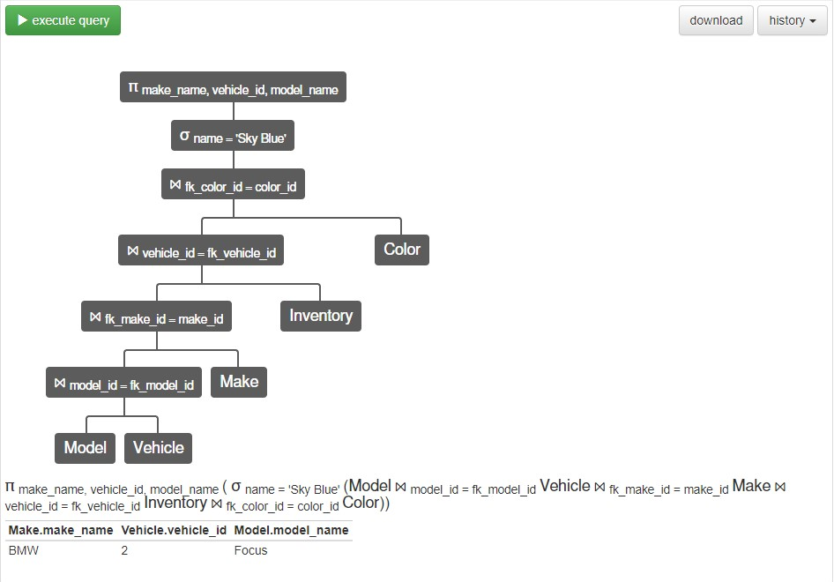

Π Player.id, Team.name, City.name (σ Player.score = 100 (Player ⋈ Player.team_id = Team.id Team ⋈Team.city_id = City.id City))

Solution 1:

**SELECT** make_name, model_name, amount **FROM** Model

**INNER JOIN** Vehicle **ON** model_id = fk_model_id

**INNER JOIN** Make **ON** make_id = fk_make_id

**INNER JOIN** Vehicle_Incentive **ON** vehicle_id = fk_vehicle_id

**INNER JOIN** Incentive **ON** fk_incentive_id = incentive_id

**WHERE type =** “dealer”;

Solution 2:

**SELECT** make_name, model_name, amount

**FROM** Model, Vehicle, Make, Vehicle_Incentive, Incentive

**WHERE** model_id = fk_model_id **AND** fk_model_id = model_id **AND** vehicle_id = fk_vehicle_id **AND** fk_incentive_id = incentive_id **AND** type = “dealer”;